**LAB 10**

**K201052**

**S.M.HASSAN ALI**

**1**

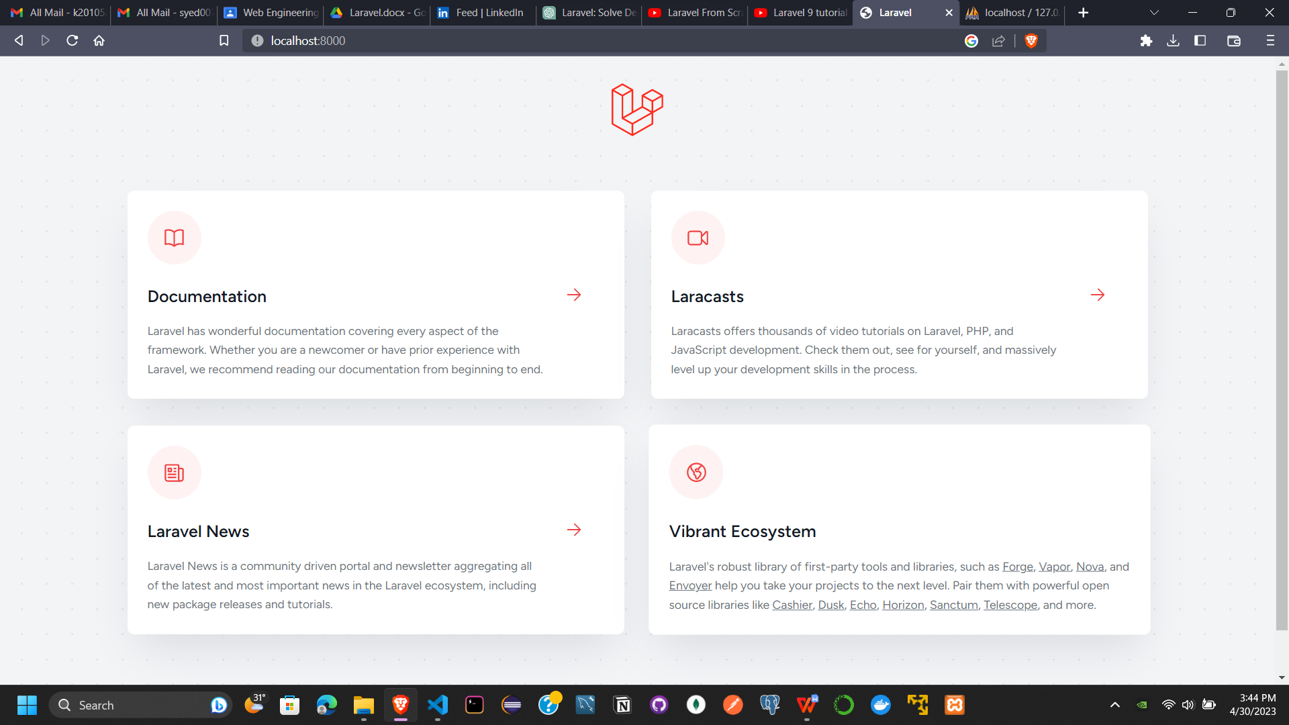

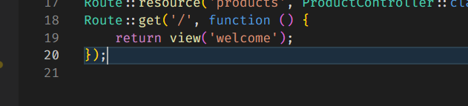

**2**

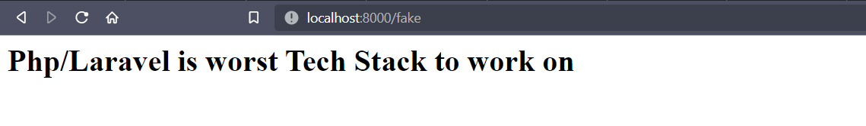

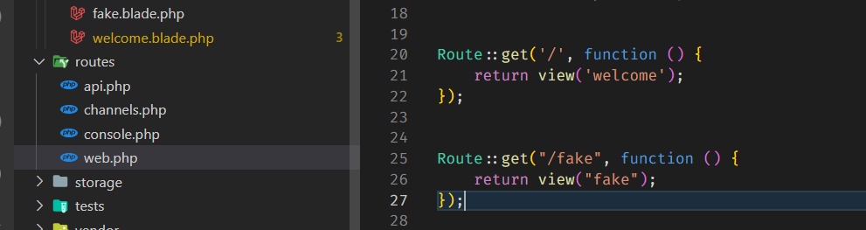

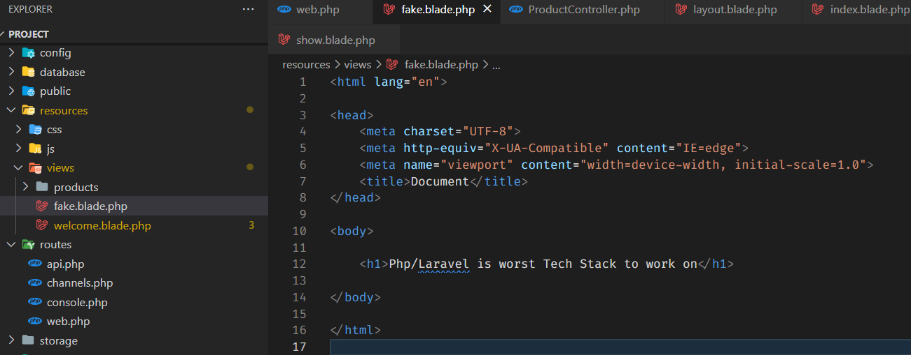

**3**

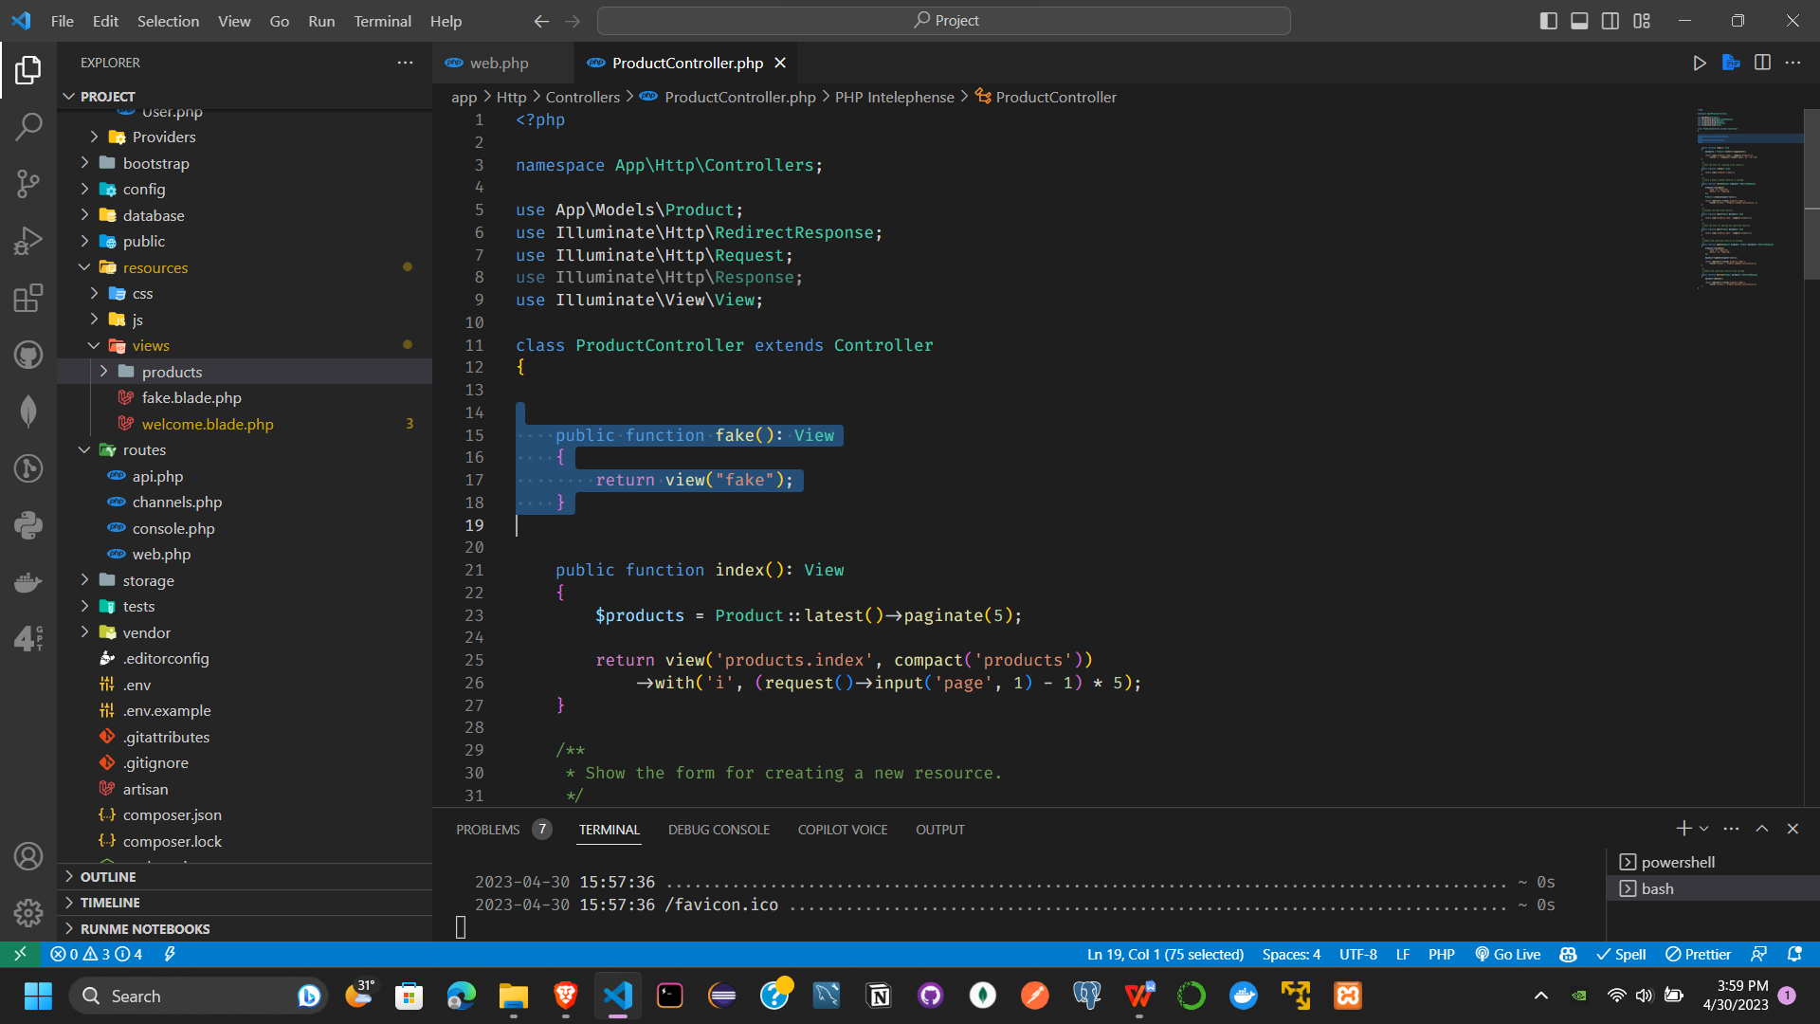

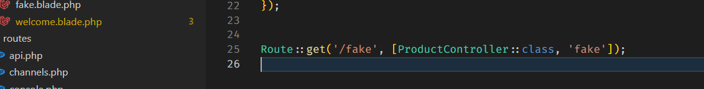



**3**

php artisan make:model Item -m

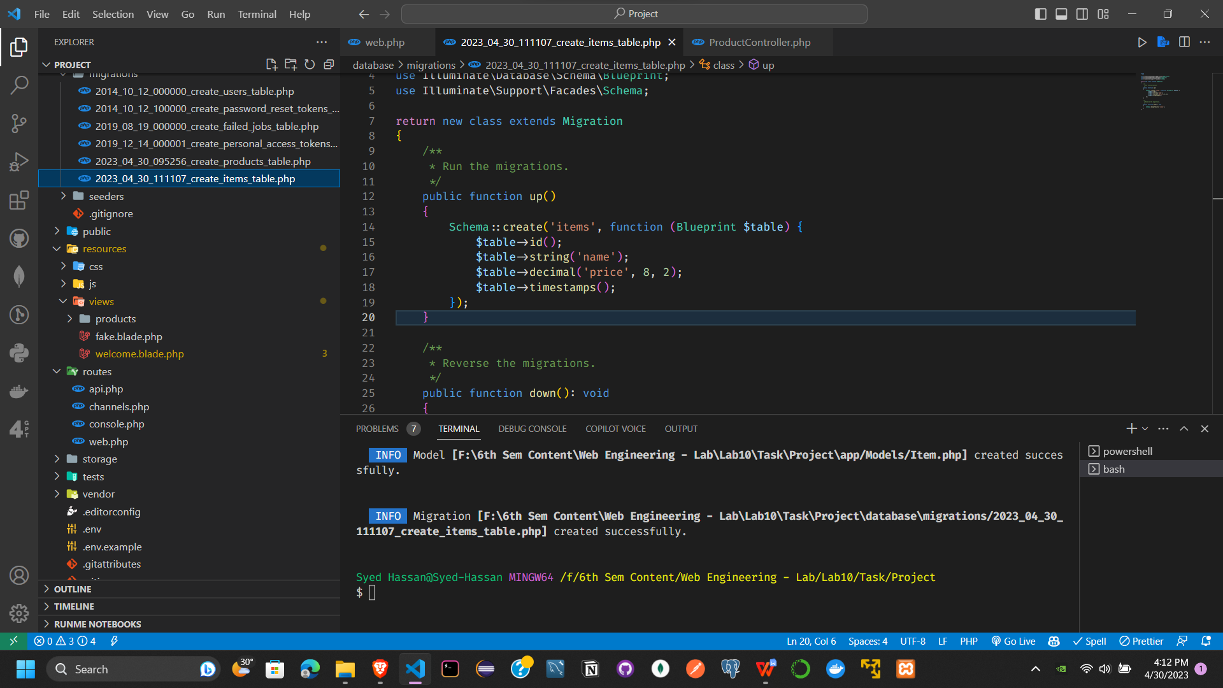

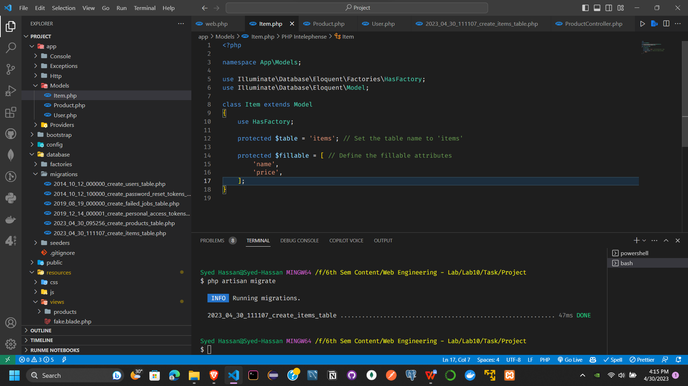

php artisan migrate

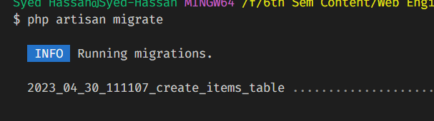

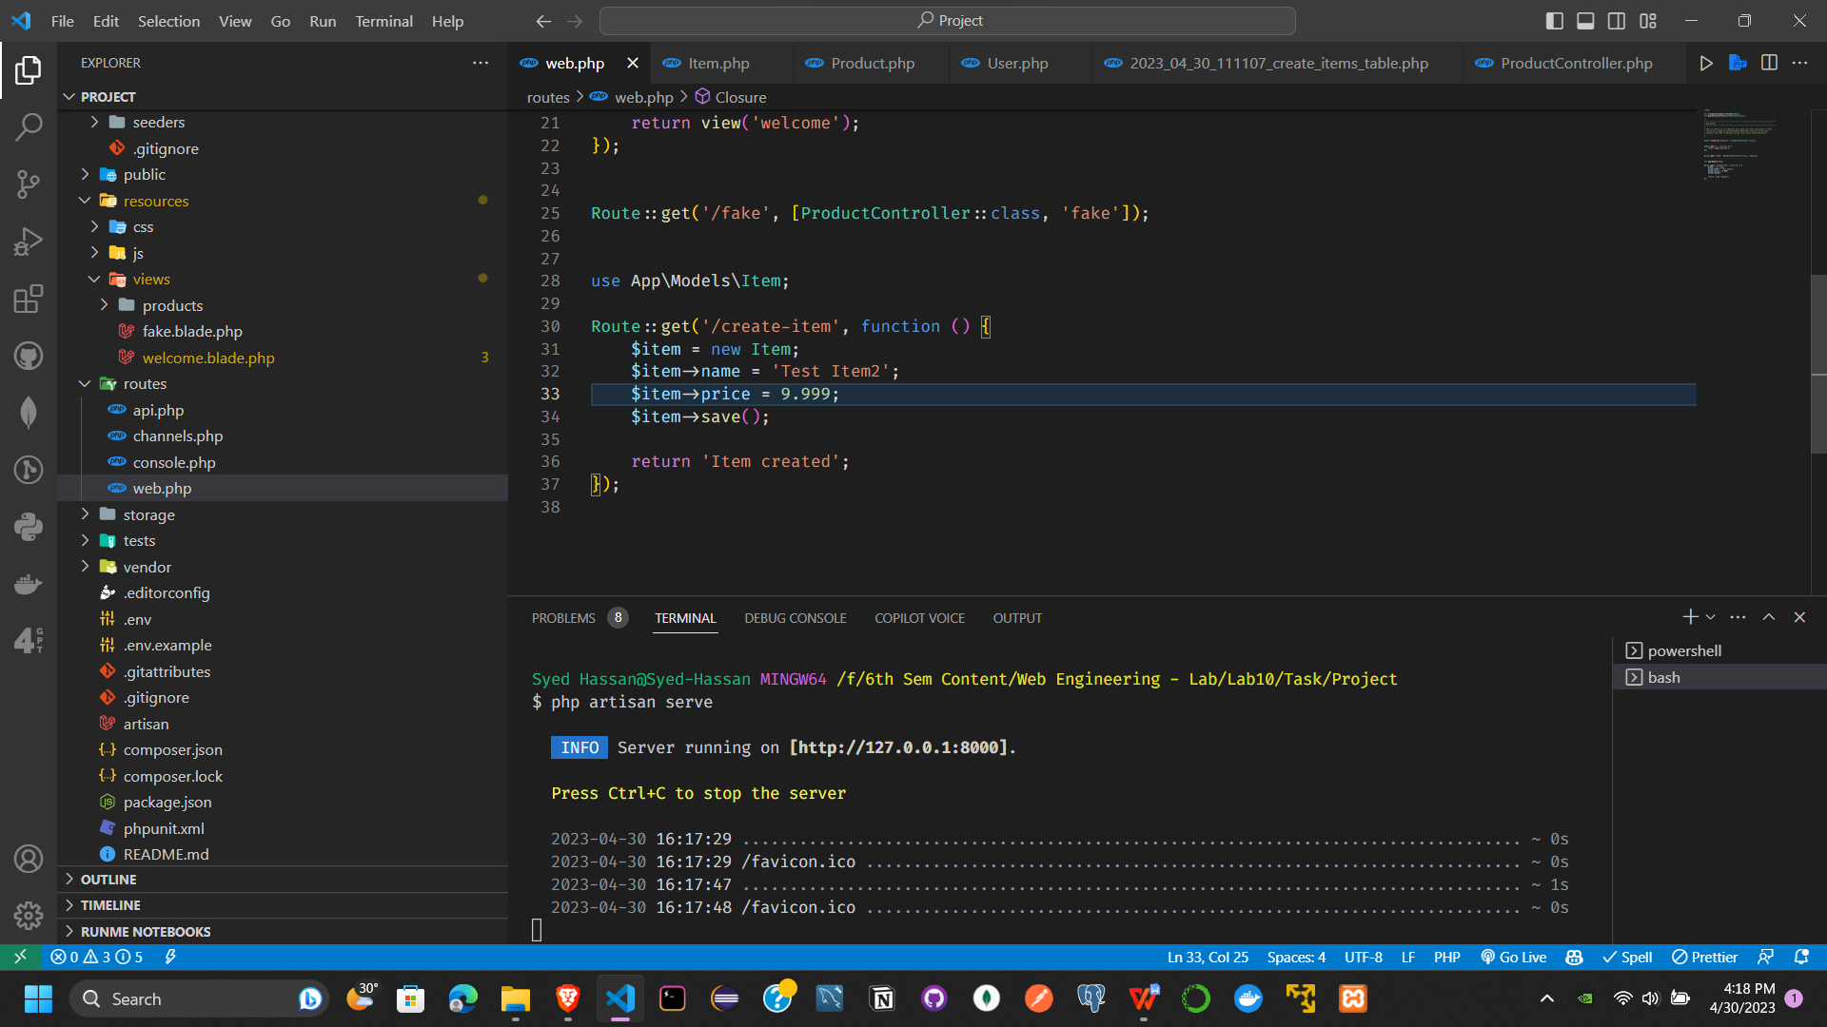

Php artisan serve

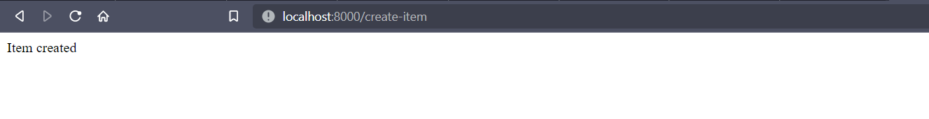

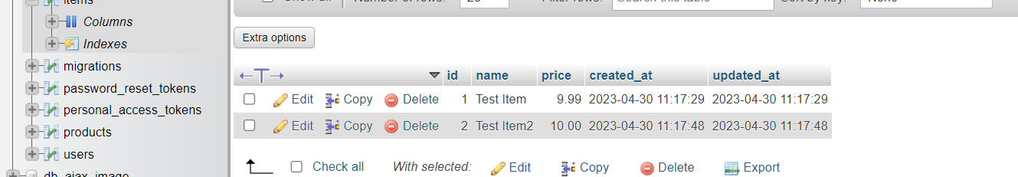

1. View already created above (fake.blade.php)

**6.**

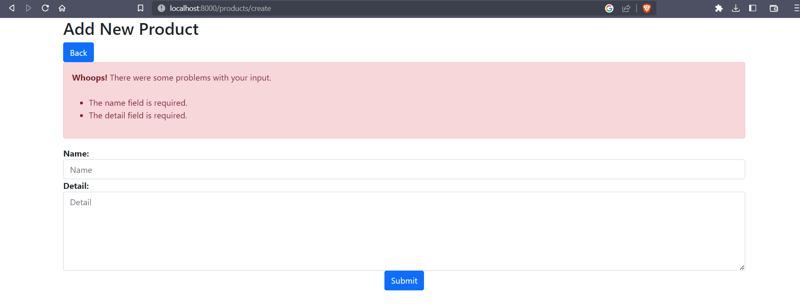

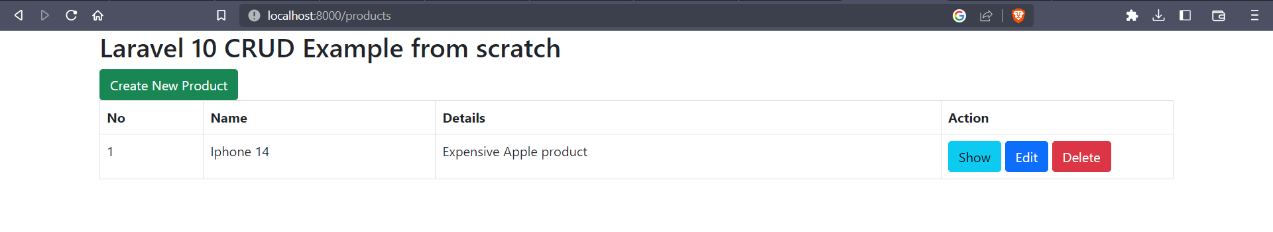



Create.blade.php

@extends('products.layout')

@section('content')

<div class="row">

    <div class="col-lg-12 margin-tb">

        <div class="pull-left">

            <h2>Add New Product</h2>

        </div>

        <div class="pull-right">

            <a class="btn btn-primary" href="{{ route('products.index') }}"> Back</a>

        </div>

    </div>

</div>

@if ($errors->any())

<div class="alert alert-danger">

    <strong>Whoops!</strong> There were some problems with your input.<br><br>

    <ul>

        @foreach ($errors->all() as $error)

        <li>{{ $error }}</li>

        @endforeach

    </ul>

</div>

@endif

<form action="{{ route('products.store') }}" method="POST">

    @csrf

    <div class="row">

        <div class="col-xs-12 col-sm-12 col-md-12">

            <div class="form-group">

                <strong>Name:</strong>

                <input type="text" name="name" class="form-control" placeholder="Name">

            </div>

        </div>

        <div class="col-xs-12 col-sm-12 col-md-12">

            <div class="form-group">

                <strong>Detail:</strong>

                <textarea class="form-control" style="height:150px" name="detail" placeholder="Detail"></textarea>

            </div>

        </div>

        <div class="col-xs-12 col-sm-12 col-md-12 text-center">

            <button type="submit" class="btn btn-primary">Submit</button>

        </div>

    </div>

</form>

@endsection

**7.**

